**PIZZA SALES SQL QUERIES**

1. **KPI’s**
2. **Total Revenue:**

select Round (SUM (total_price),2) as Total_Revenue from pizza_sales.

1. **Average Order Value:**

select Round(sum(total_price)/count(Distinct order_id),2) as Avg_order_value from pizza sales.

1. **Total Pizzas Sold:**

select sum(quantity) as Total_Pizzas from pizza_sales.

1. **Total Orders:**

select count (Distinct order_id) as Total_Orders from pizza_sales.

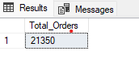

1. **Average Pizzas Per Order:**

select sum(quantity)/count(distinct order_id) as Pizzas_per_Order from pizza_sales

1. **Daily Trends for Total Orders:**

select DATENAME(DW,order_date)as order_day,count(distinct order_id) as Total_orders from pizza_sales group by DATENAME(DW,order_date)

1. **Monthly Trends for Total Orders:**

select Datename(month,order_date)as order_month,count(distinct order_id) as Total_orders from pizza_sales group by DATENAME(month,order_date)

1. **Percentage of sales by pizza category:**

select pizza_category,sum(total_price)*100/(select sum(total_price)from pizza_sales)as Sales_percentage from pizza_sales group by pizza_category

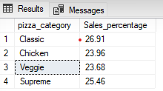

1. **Percentage of sales by pizza size:**

select pizza_size,Round(sum(total_price)*100/(select sum(total_price)from pizza_sales),2)as Sales_percentage from pizza_sales group by pizza_size

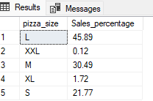

1. **Top 5 best sellers by Revenue, Total Quantity and Total Orders:**

**For Revenue-**

select Top 5 pizza_name,sum(total_price) as Total_Revenue from pizza_sales

group by pizza_name order by Total_Revenue desc

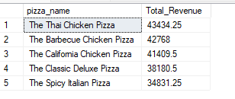

**For Tota Quantity -**

select Top 5 pizza_name,sum(quantity) as Total_Quantity from pizza_sales

group by pizza_name order by Total_Quantity desc

**For Total Orders:**

select Top 5 pizza_name,count(distinct order_id) as Total_Orders from pizza_sales

group by pizza_name order by Total_Orders desc

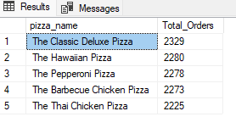

1. **Bottom 5 sellers by Revenue, Total Quantity and Total Orders:**

**For Revenue-**

select Top 5 pizza_name,sum(total_price) as Total_Revenue from pizza_sales

group by pizza_name order by Total_Revenue asc

**For Total Quantity-**

select Top 5 pizza_name,sum(quantity) as Total_Quantity from pizza_sales

group by pizza_name order by Total_Quantity asc

**For Total Orders-**

select Top 5 pizza_name,count(distinct order_id) as Total_Orders from pizza_sales

group by pizza_name order by Total_Orders asc

